**Amazon EKS (Managing the Kubernetes Services using AWS)**

1. Login to Amazon EKS console

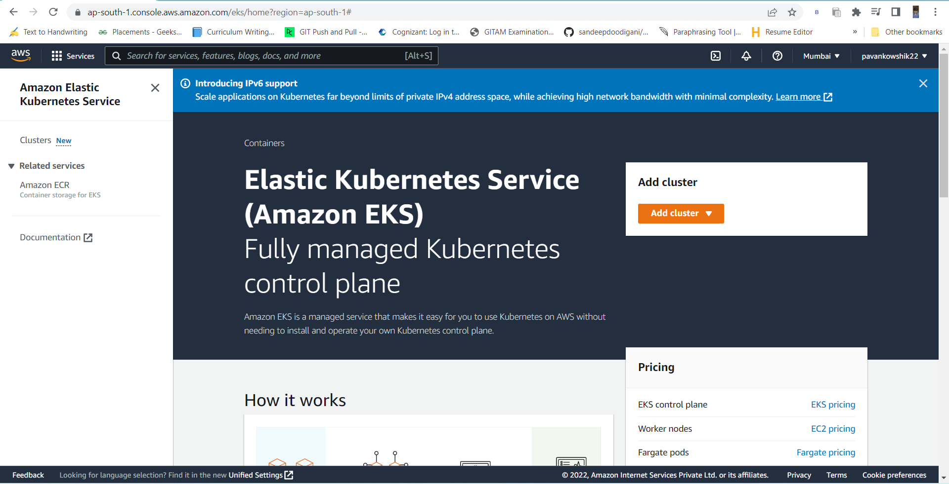

1. In this, we are installing kubernetes in aws follow the following actions

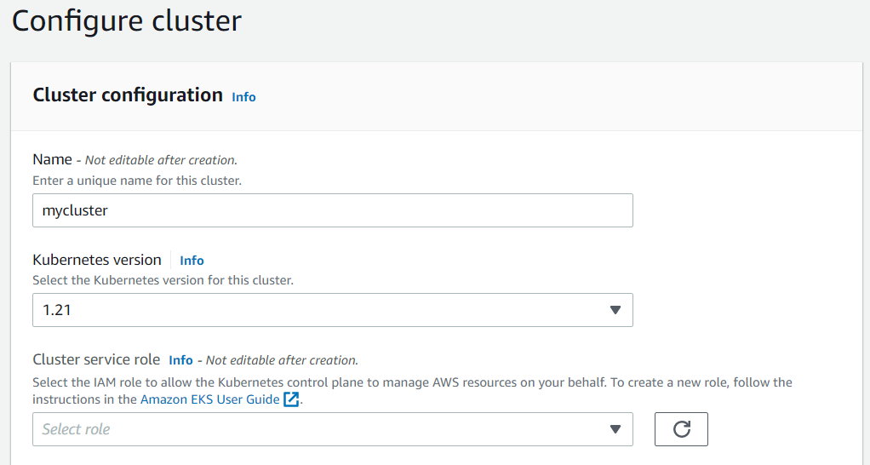

1. Now we need to create a role , click on Amazon EKS User Guide.

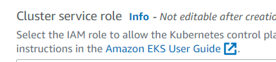

1. Follow the following actions to create an role



1. Click on create role and follow the actions below

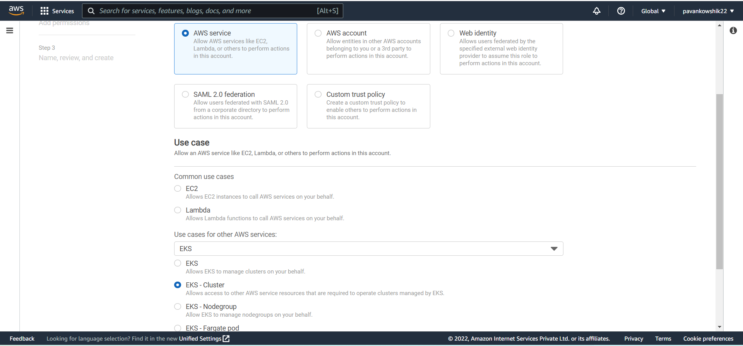

1. Click on Next

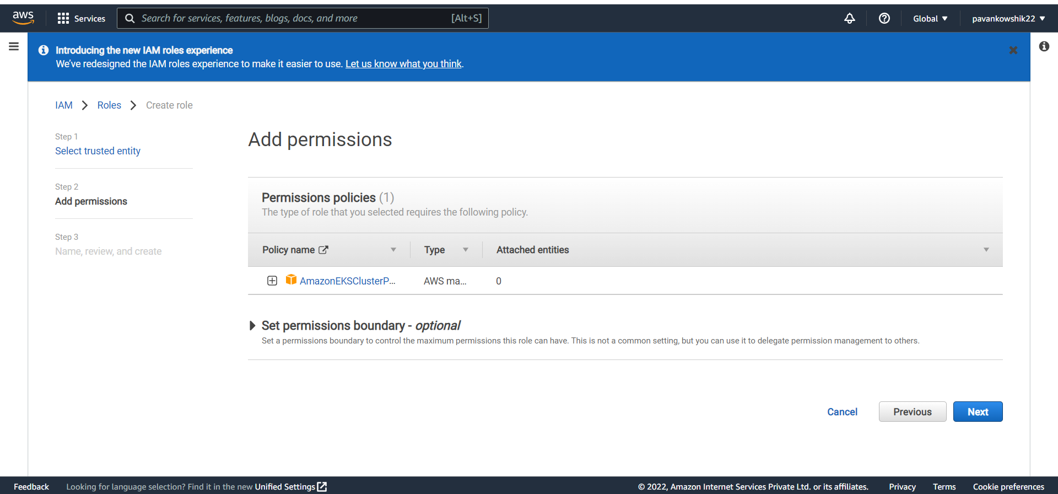

1. Then follow actions as follows

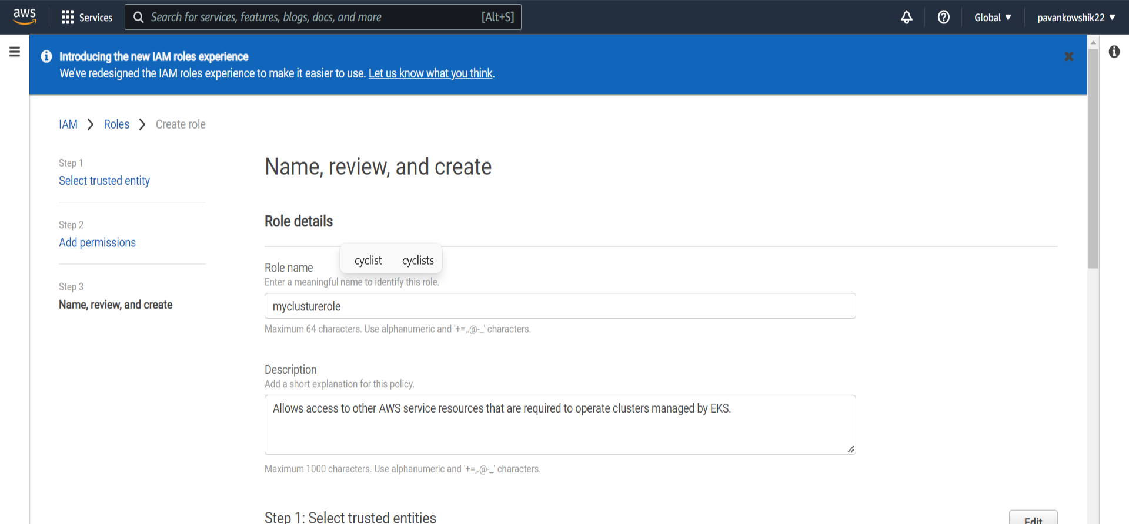

1. Go back to the original page and click on reload

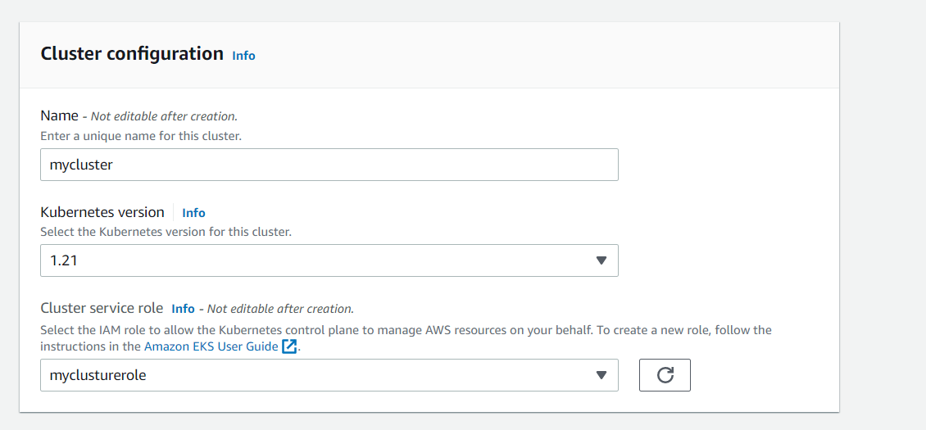

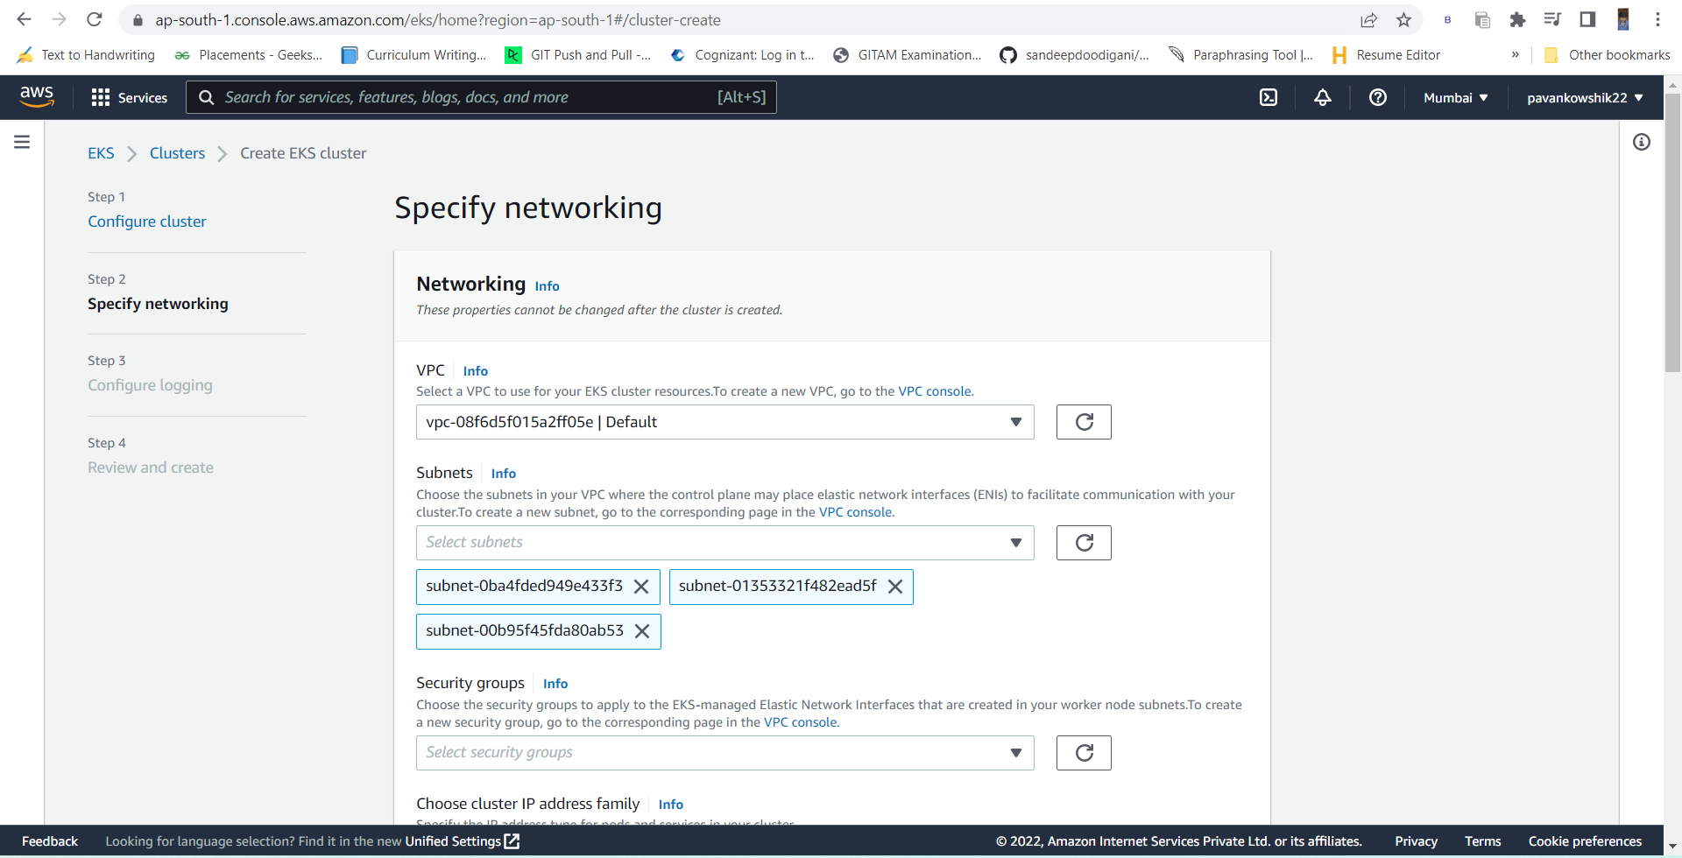

Now do not change the next pages and create a role

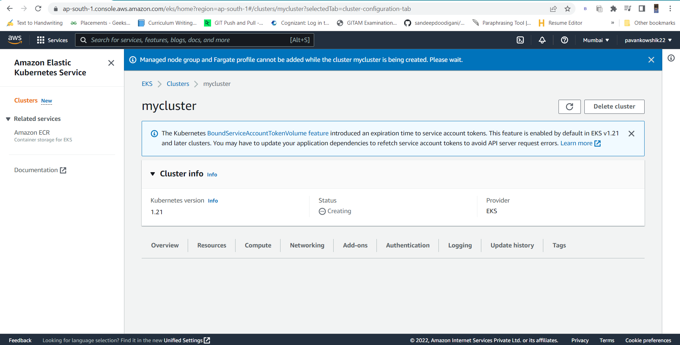

1. Aws – version
2. Now we need to install amazon CLI in command prompt

<https://docs.aws.amazon.com/cli/v1/userguide/install-windows.html>

or use the command in command prompt

msiexec.exe /i <https://awscli.amazonaws.com/AWSCLIV2.msi>

1. Now go to IAM connect command prompt to aws account

Click on [My security credentials](https://us-east-1.console.aws.amazon.com/iam/home#/security_credentials)

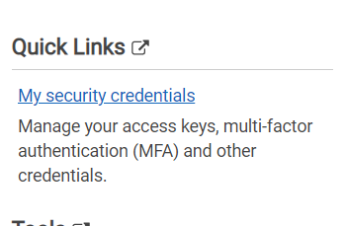

1. Click on Create new access key and download the key File

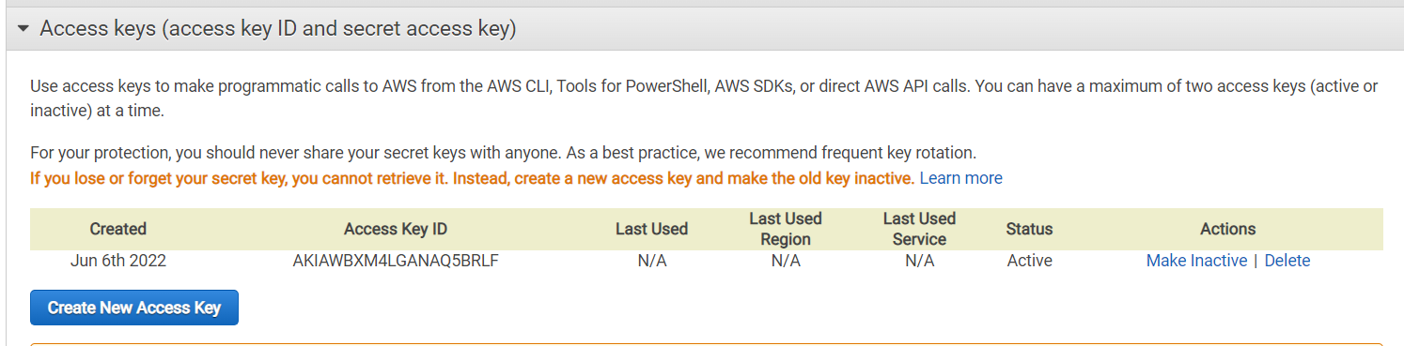

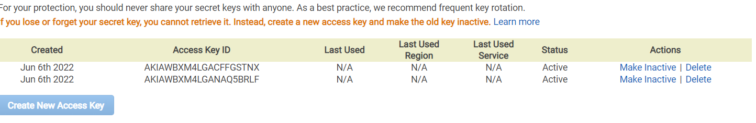

1. Open the file and copy the access key and username
2. Now open the command prompt and follow

aws configure

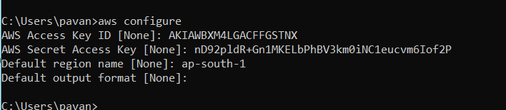

In command prompt follow the commands

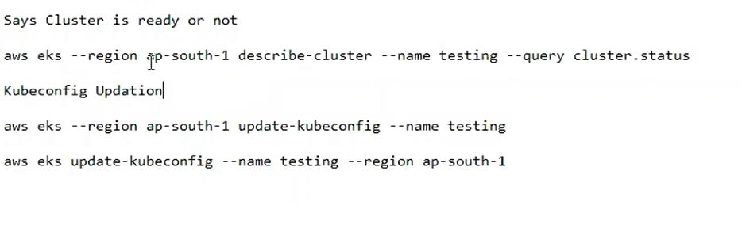

aws eks --region ap-south-1 describe-cluster --name mycluster --query cluster.status



* Till now the clusture is having master node, we don’t have worker node
* Now we need to configure Kubectl

aws eks --region ap-south-1 update-kubeconfig --name mycluster



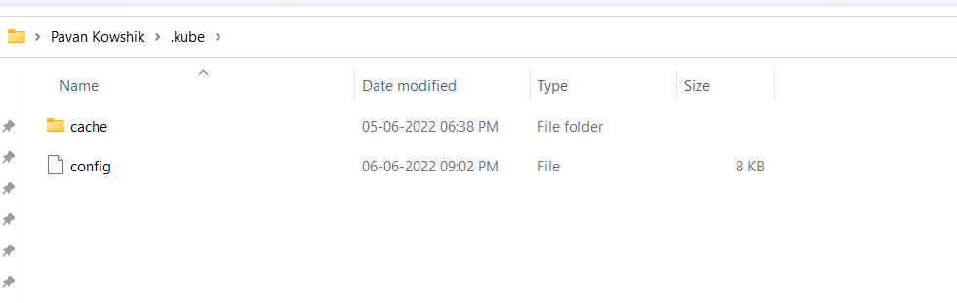

kubectl get svc (we get services)

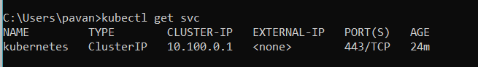

1. Now we are configuring worker node.Open the clusture and click on Compute

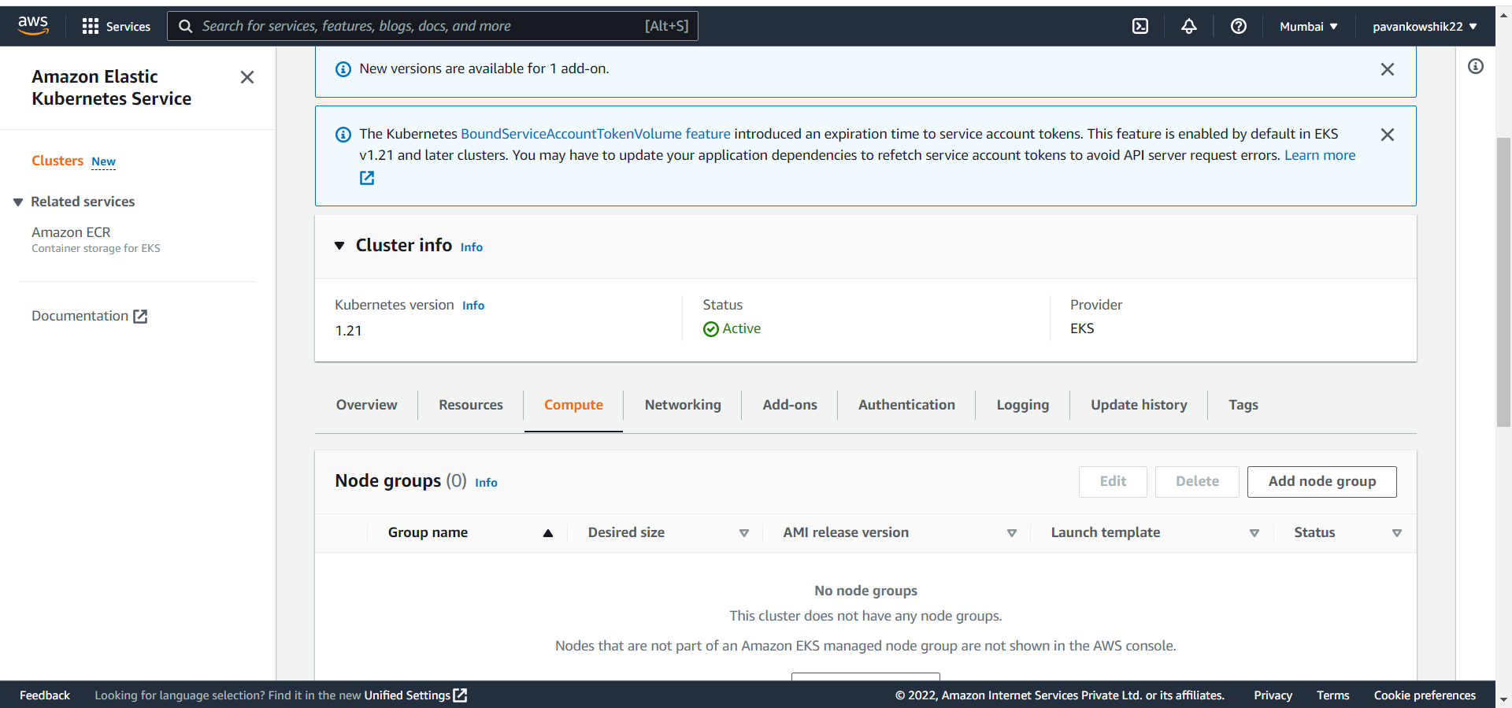

Click on worker node

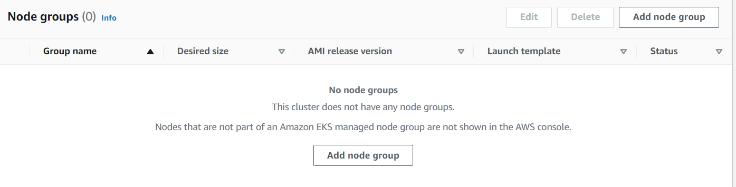

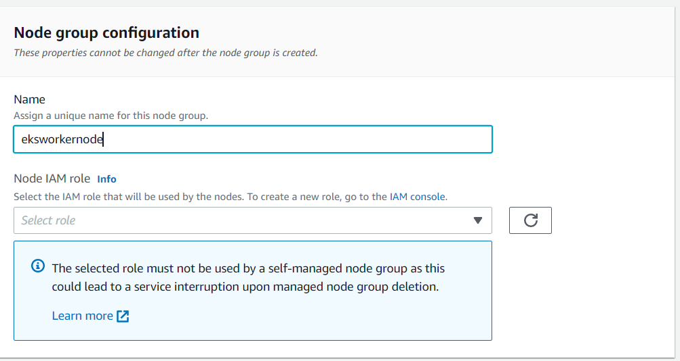

Click on IAM Console and click on create role

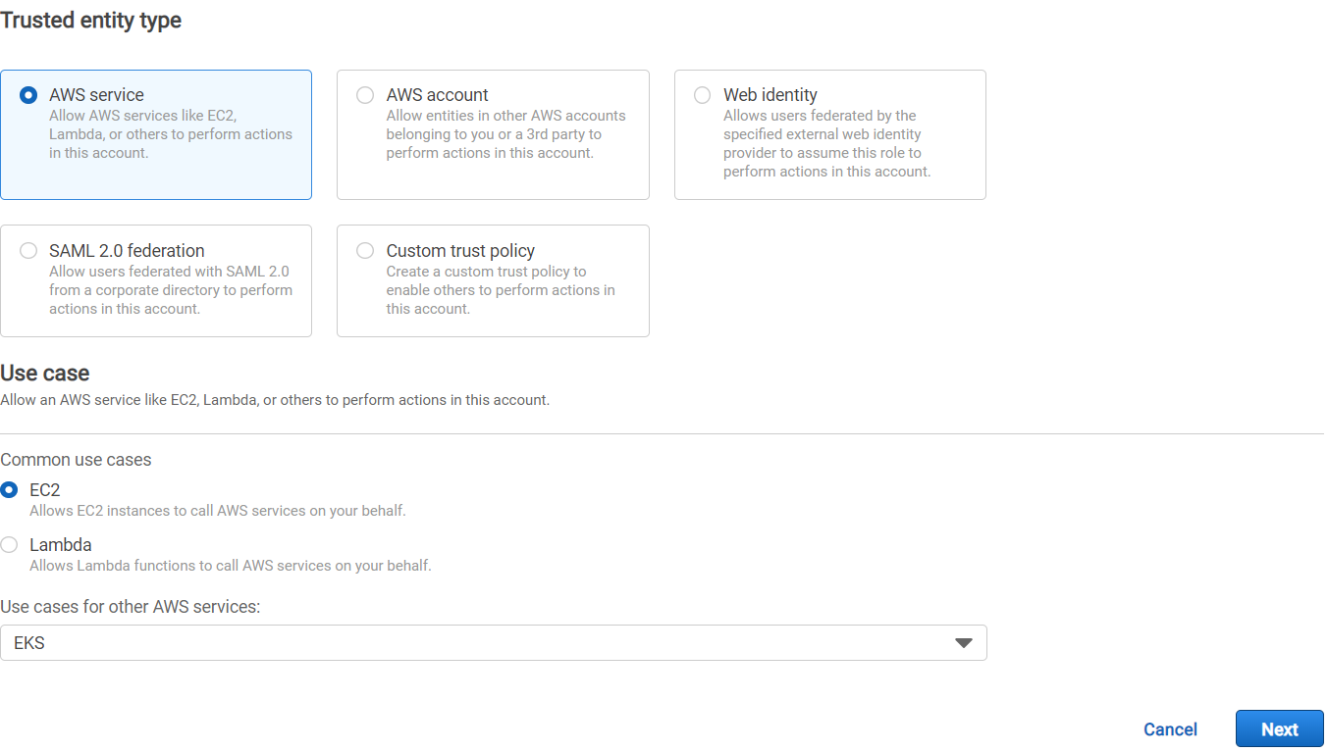

Select the following properties

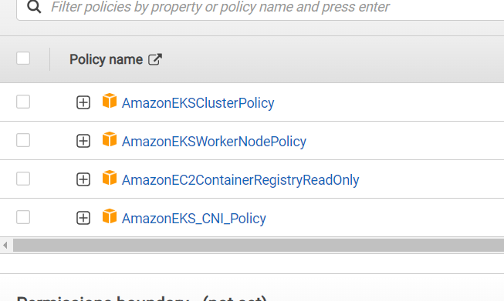

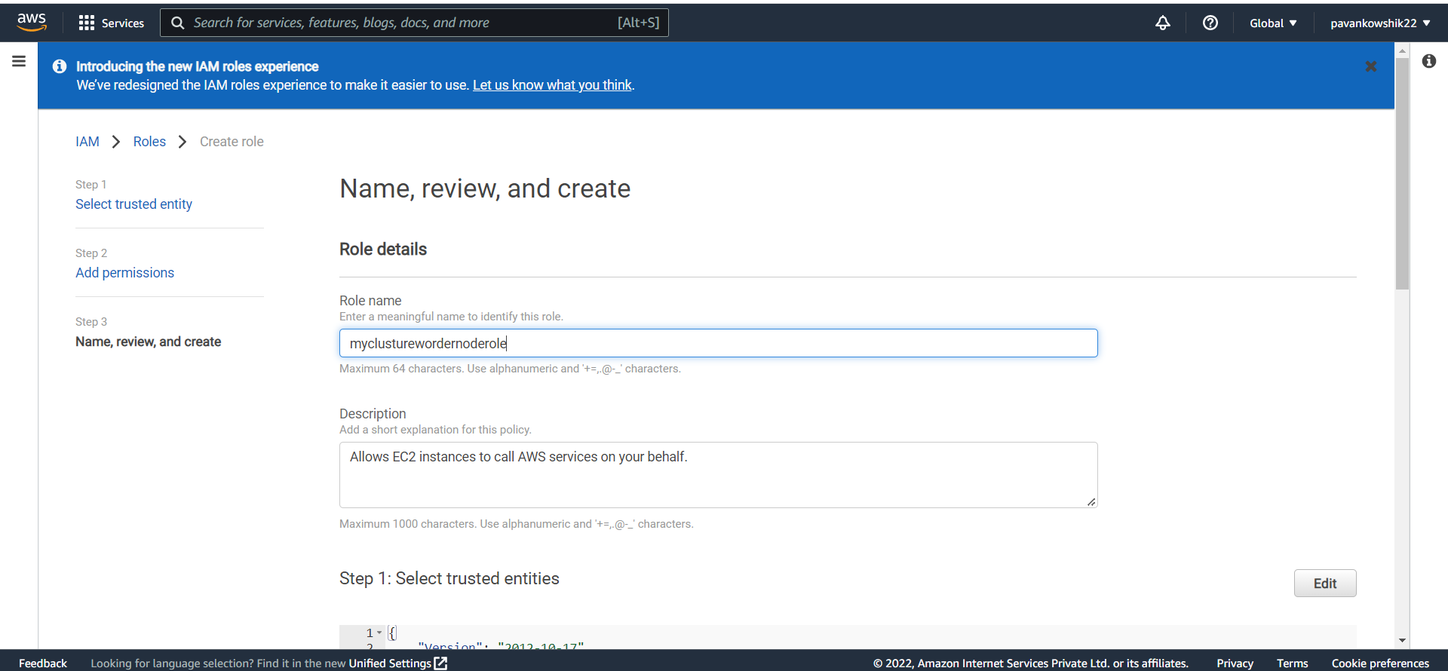

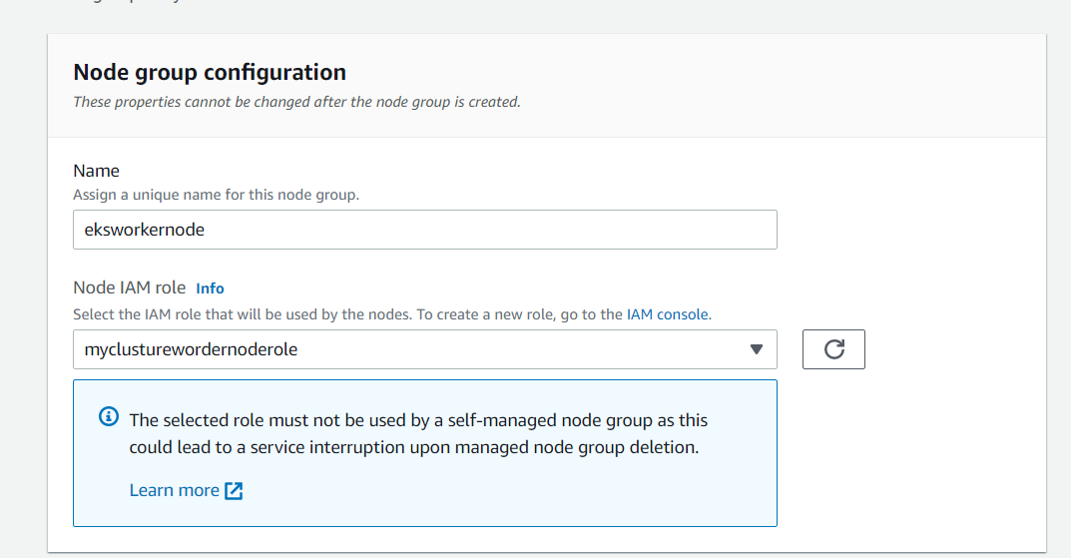

Click next button

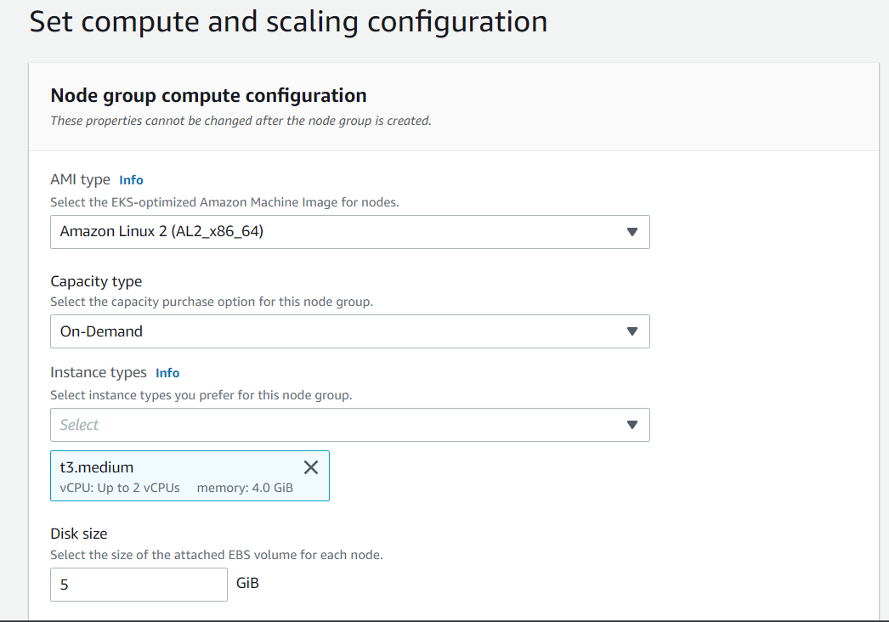

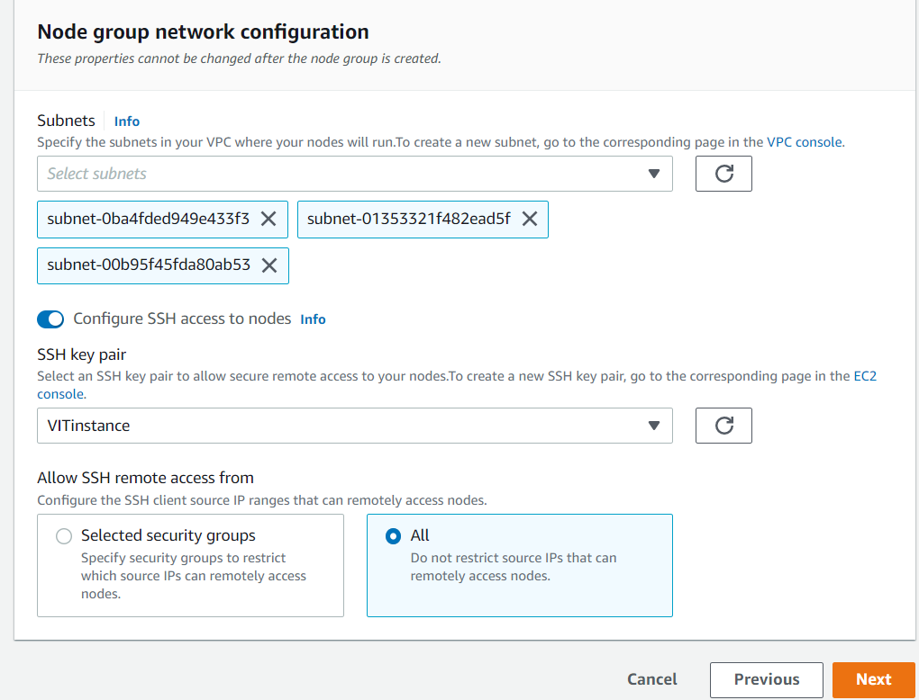

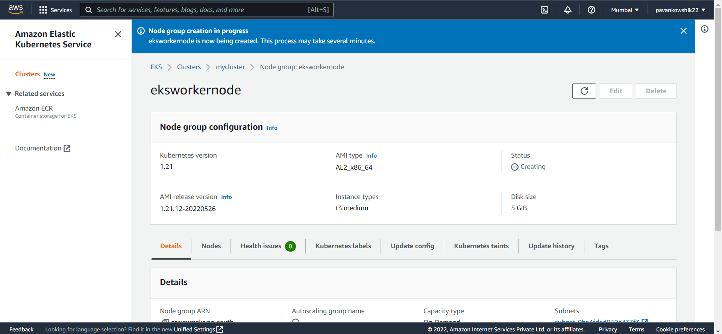

Now we need to deploy the application to EKS Clusture

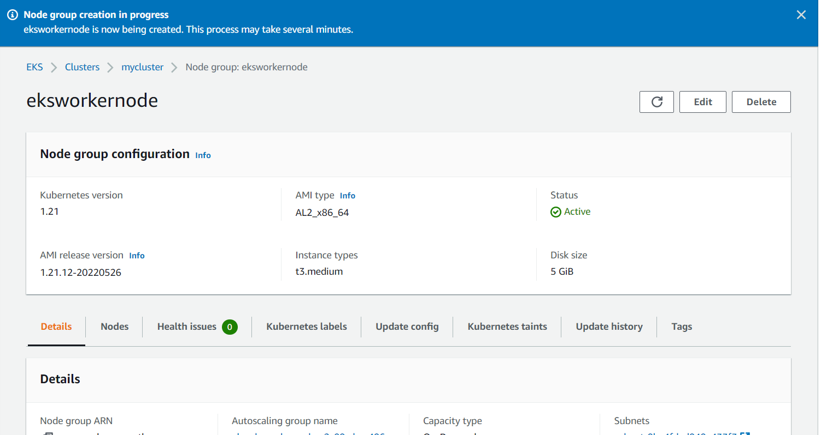

Kubectl get nodes (These are worker Nodes)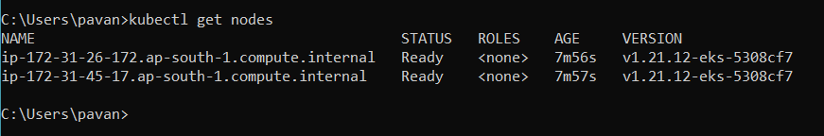

* Now we are deploying the hello world application in AWS

kubectl apply -f <https://k8s.io/examples/service/access/hello-application.yaml>

kubectl get deployment

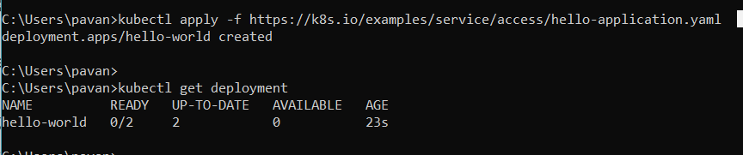

kubectl get pods

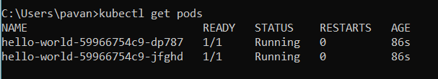

kubectl expose deployment hello-world --type=NodePort --name=example-service



kubectl describe services example-service

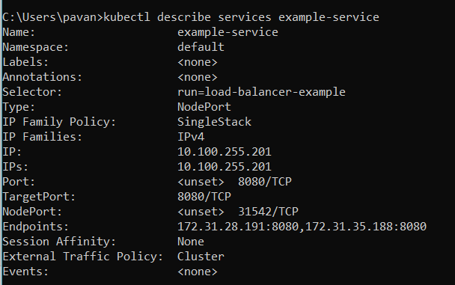

Now go to EC2 Instance and open the instance

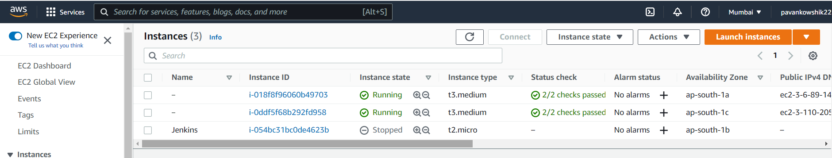

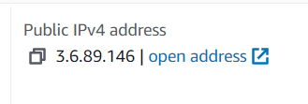 copy the address and add the peot address to it

<http://3.6.89.146:31542/>

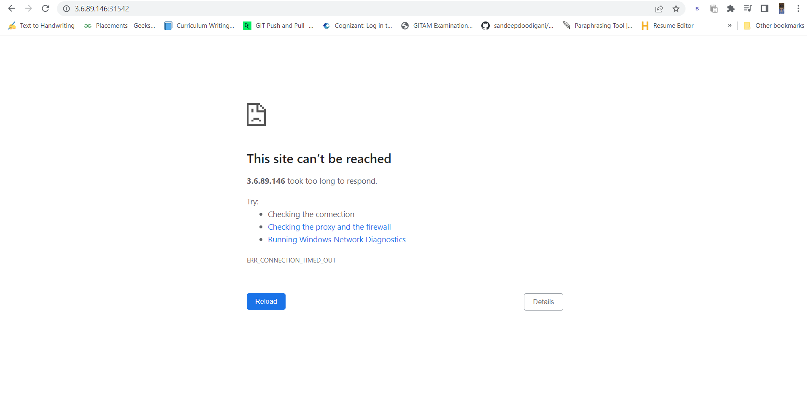

No we need to enable the port

* Go to EC2 inastance
* Go to security group

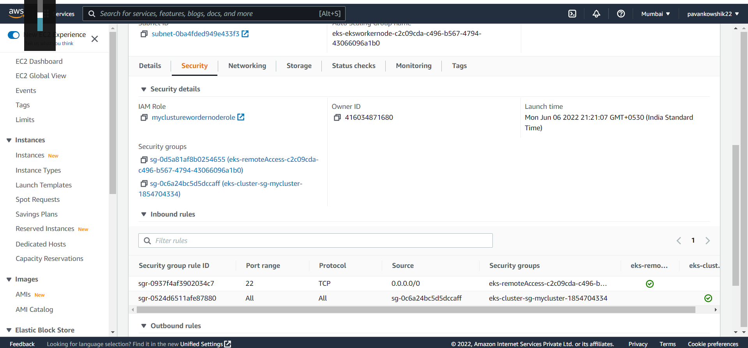

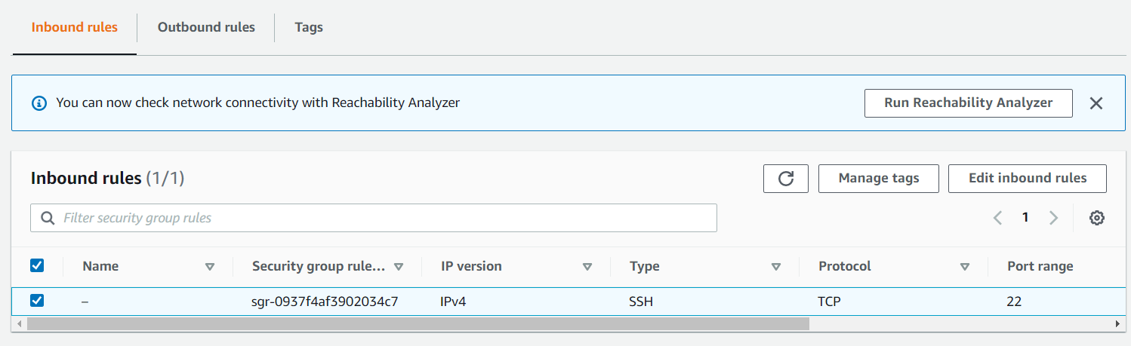

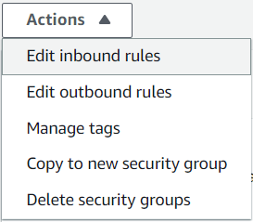

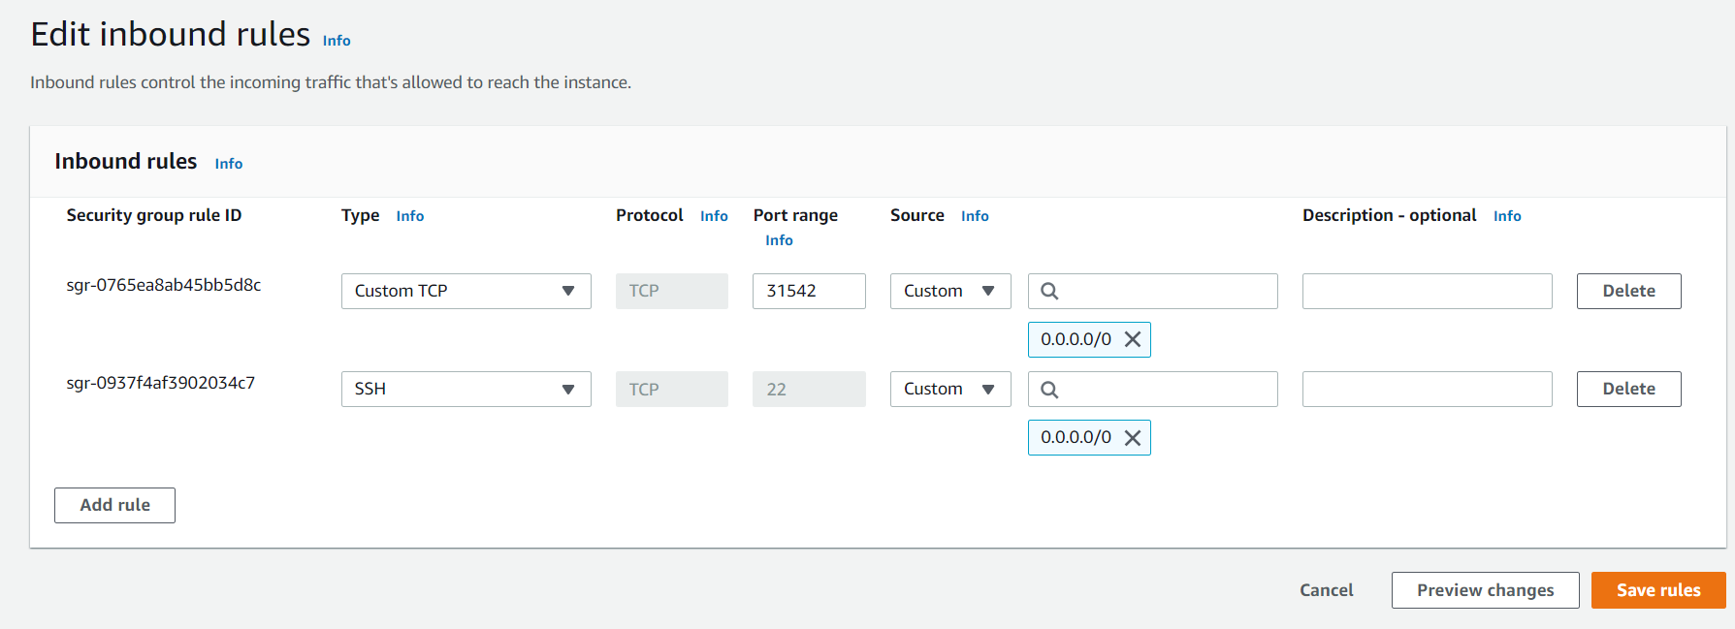

<http://3.6.89.146:31542/>



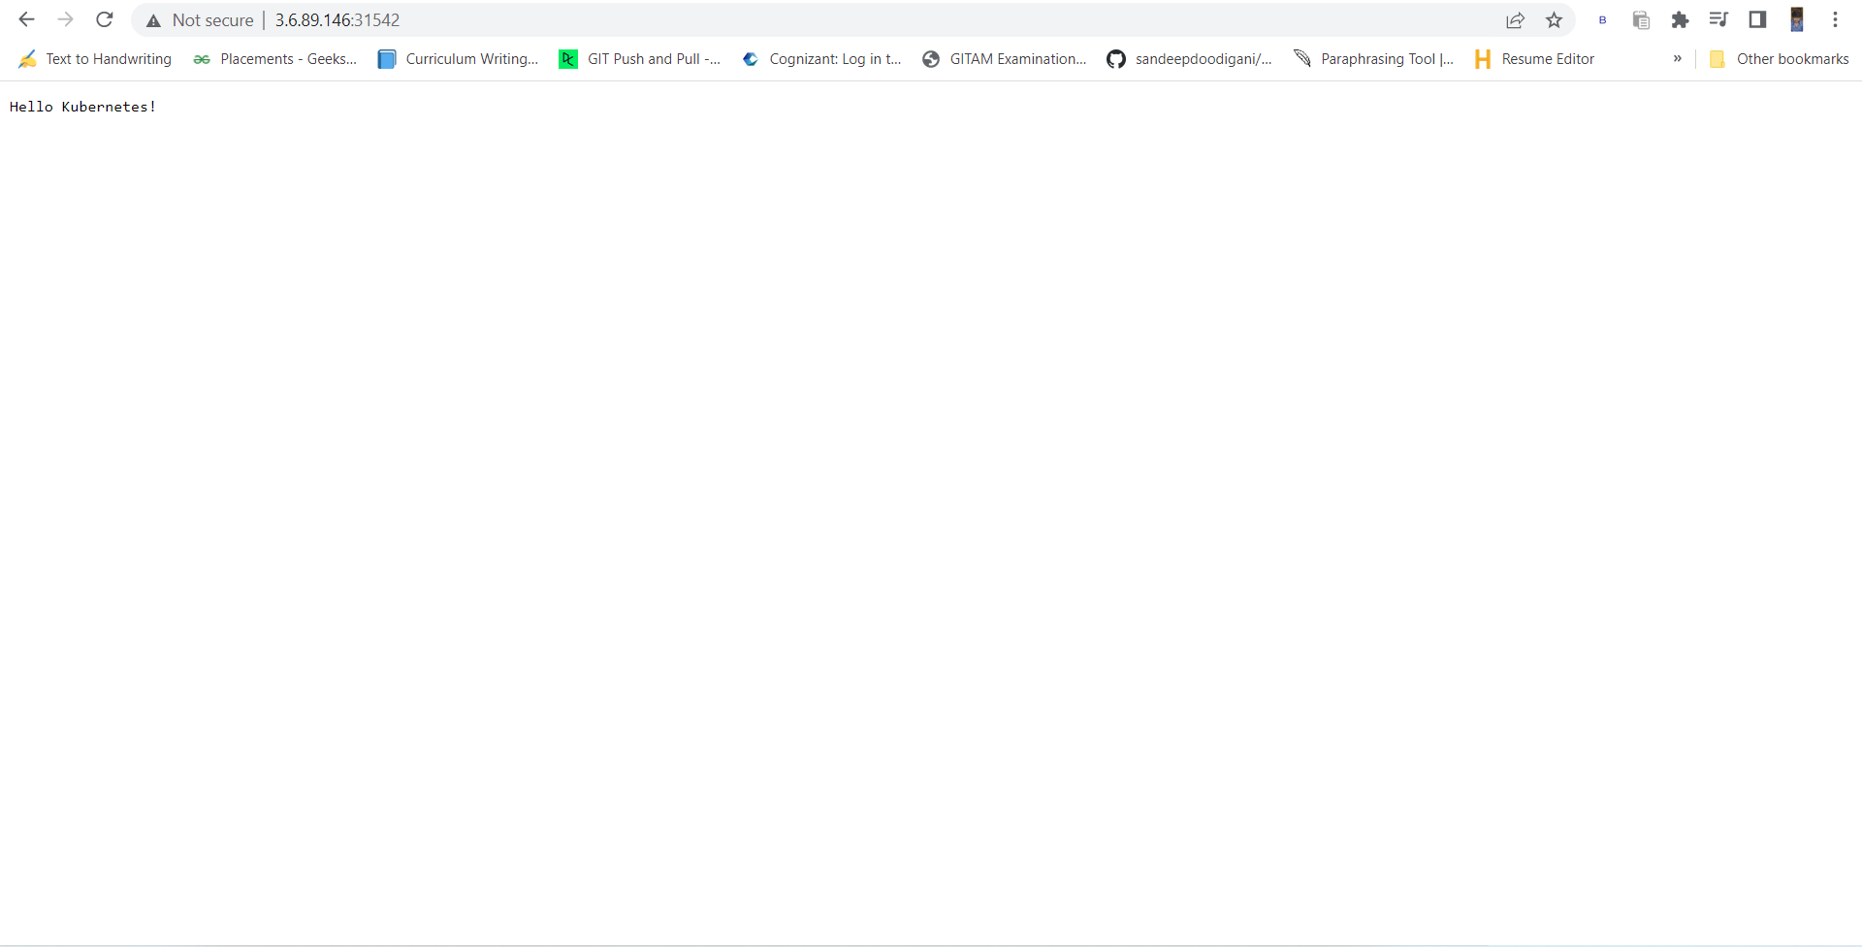

Now we are terminating all the services

1. kubectl delete deployment hello-world
2. kubectl delete service example-service

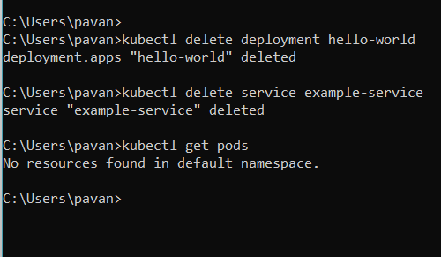

Delete worker node

